Market Monitor - Democratic Republic of the Congo - 2026-03

Highlights
The cost of food rose significantly in March, driven by sharp monthly price increases for key staples, particularly processed grains and beans. This upward trend in the food basket occurred despite a notable drop in the price of raw maize grain and palm oil.
The cost of the food basket increased by 10.3% month-on-month (↑5.4% YoY). The most significant price changes were observed for Wheat flour (↑17.2% MoM), Beans (↑14.4% MoM), and Maize (↓33.5% MoM).
Key market drivers this month include:
- Sharp monthly price increases in key processed staples, including Wheat flour (↑17.2%) and Beans (↑14.4%), which were the primary drivers of the food basket's inflation.
- A steep decline in the price of raw Maize grain (↓33.5%), which contrasted sharply with the price increase for Maize flour (↑2.8%).
- A continued decrease in the price of Palm oil, which fell by 9.9% month-on-month and 16.5% year-on-year.
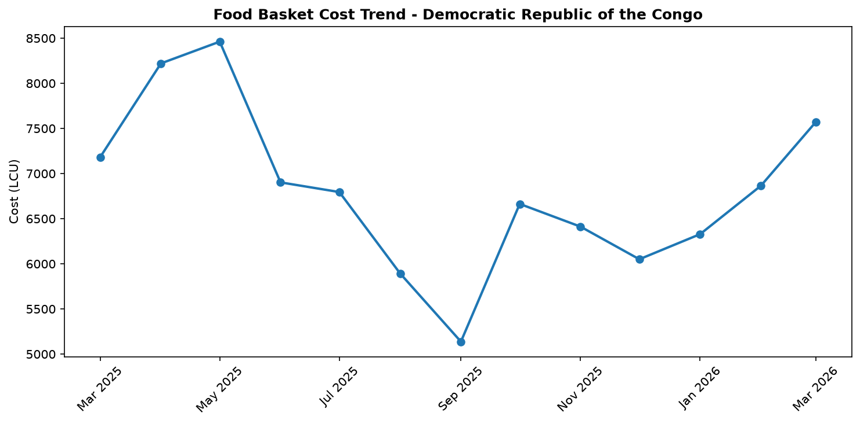
Food basket cost trend

Market Overview
Market conditions in the Democratic Republic of the Congo deteriorated in March, marked by a significant acceleration in food prices. The cost of the reference food basket surged by 10.3% month-on-month, reaching 7571.33, a stark contrast to the more moderate year-on-year increase of 5.4%. This sharp inflationary trend is primarily driven by substantial price hikes in key staple foods. Processed grains were a major contributor, with wheat flour prices climbing by a staggering 17.2% and maize flour increasing by 2.8% over the last month. The most significant driver, however, was the price of beans, a critical protein source, which saw a sharp 14.4% monthly increase. These price pressures are occurring within a context of worsening security in the eastern provinces, where conflict is disrupting agricultural activities, supply chains, and household incomes. The strong monthly inflation across essential commodities suggests that upward pressure on food prices will likely continue in the near term, further straining the purchasing power of vulnerable households across the country.

Commodity Analysis
A detailed commodity analysis reveals a complex market with diverging trends, though the overall movement for staple foods is inflationary. The food basket's 10.3% monthly increase was led by beans, which jumped 14.4% month-on-month (+5.2% year-on-year), and maize flour, which rose 2.8% month-on-month (+5.9% year-on-year). It is important to note the current basket calculation is based on beans and maize flour, as data for cassava was unavailable. Wheat flour experienced the most dramatic monthly surge at +17.2%, though its price remains 8.2% below last year's level. In a striking divergence, the price of raw maize grain plummeted by 33.5% from the previous month and is down 46.9% annually. This sharp disconnect between the falling price of raw grain and the rising price of maize flour points to significant bottlenecks or costs in processing, distribution, or other market pressures that are passed on to consumers. In contrast to most staples, palm oil prices continued a downward trend, decreasing by 9.9% month-on-month and 16.5% year-on-year, providing some minor relief. Imported rice saw a slight monthly increase of 3.6% but also remains cheaper than a year ago (-6.5%).
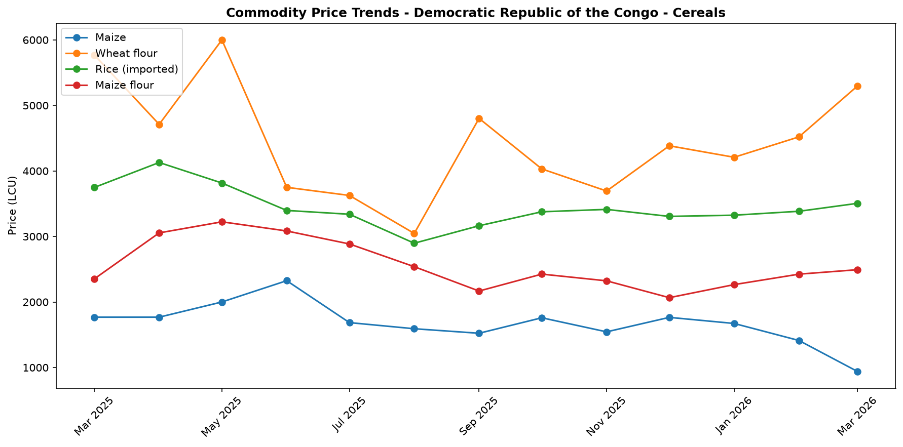
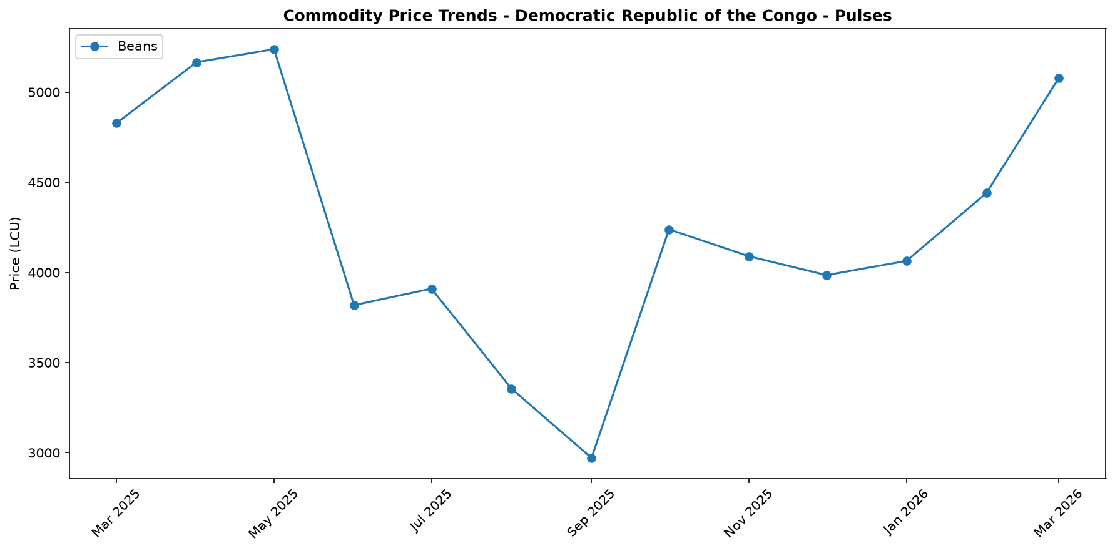
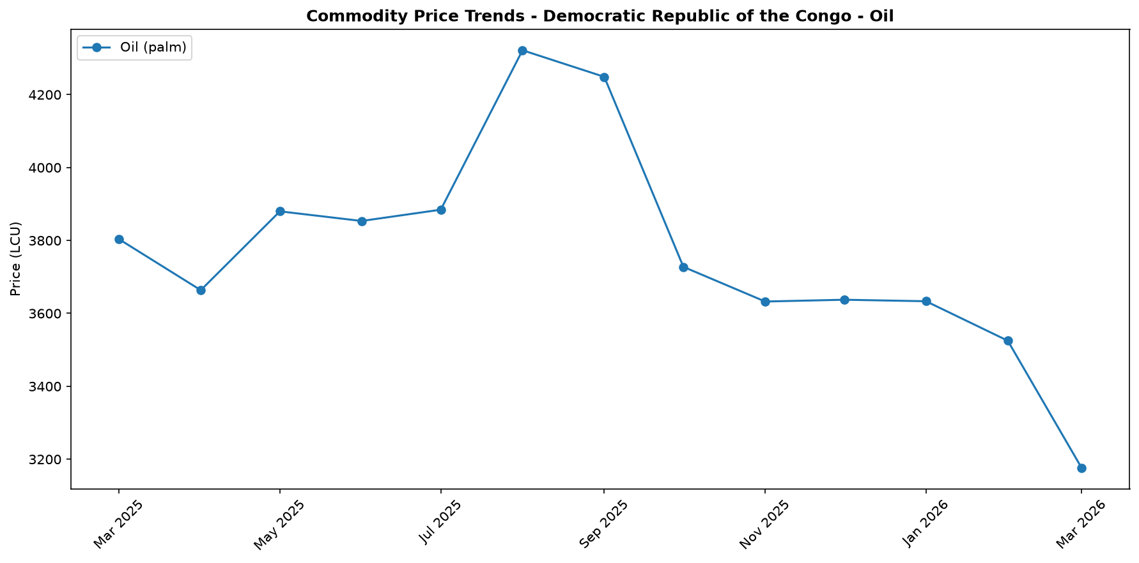

Regional Highlights
The eastern provinces remain the epicenter of a severe and deteriorating humanitarian crisis, which is having a direct impact on food security and market stability. Reports from March confirm that escalating armed conflicts are driving significant new population displacements, further straining resources in host communities. The conflict is severely curtailing household access to critical income-generating activities, including artisanal mining, fishing, and petty trade, crippling local economies and reducing purchasing power. Furthermore, the crisis is directly impacting food production, as persistent insecurity and displacement have reduced household access to arable land. This has resulted in Crisis (IPC Phase 3) and Emergency (IPC Phase 4) food security outcomes for many poor and displaced households. These disruptions to agricultural production and supply chains in the east are a likely contributing factor to the national price increases observed for key staples such as beans and maize flour.
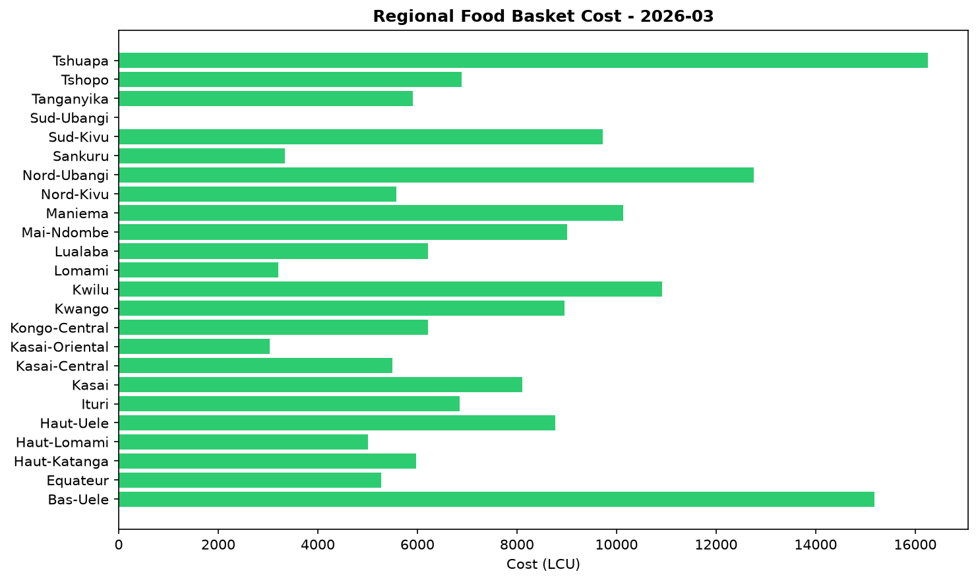

References
- [rw_4205328] ReliefWeb (2026-03-31) West and Central Africa: Latest Events at a glance (24 - 30 March 2026)
https://reliefweb.int/node/4205328
- [rw_4205276] ReliefWeb (2026-03-31) What Is Therapeutic Milk? Treating Severe Child Malnutrition
https://reliefweb.int/node/4205276
- [rw_4205138] ReliefWeb (2026-03-30) IRC warns Iran war is disrupting fuel and aid supply chains, threatening life-saving operations across Africa
https://reliefweb.int/node/4205138
- [rw_4204988] ReliefWeb (2026-03-30) Democratic Republic of Congo Food Security Outlook February, September 2026 - May 2025: Multifaceted conflicts continue to hinder household food security
https://reliefweb.int/node/4204988
- [rw_4204696] ReliefWeb (2026-03-27) War-related disruptions in the Middle East are delaying lifesaving reproductive health supplies for women and girls worldwide
https://reliefweb.int/node/4204696
- [rw_4204665] ReliefWeb (2026-03-26) République Démocratique du Congo : une crise sans fin
https://reliefweb.int/node/4204665
- [rw_4204486] ReliefWeb (2026-03-26) UNICEF West and Central Africa Region Humanitarian Situation Report No. 2 (End of Year), 31 December 2025
https://reliefweb.int/node/4204486
- [rw_4204471] ReliefWeb (2026-03-25) Democratic Republic of Congo | Population Movement - Operation Update #6 (MDRCD043)
https://reliefweb.int/node/4204471
- [rw_4204453] ReliefWeb (2026-03-25) Keynote Speech of SRSG Patten at the high-level side event “Turning Partnership into Protection for SGBV Survivors, insights from the DRC”, 12 March 2026, New York
https://reliefweb.int/node/4204453
- [rw_4204273] ReliefWeb (2026-03-24) West and Central Africa: Latest Events at a glance (17 - 23 March 2026)
https://reliefweb.int/node/4204273
- [seerist_1027895] Seerist (2026-03-24) Militant attacks on mining sites in Ituri highlight continued security risks
- [seerist_1027882] Seerist (2026-03-23) Government to step up enforcement after mining fatalities but structural pressures will limit lasting impact
- [seerist_1027861] Seerist (2026-03-20) Big Picture series: Beyond health – the implications of the America First Global Health Strategy
- [seerist_1027812] Seerist (2026-03-18) M23, DRC army to trade blame for aid worker’s death; aid operations in east to face continued security threats
- [seerist_1027740] Seerist (2026-03-12) Lethal attack on conservation agency base in Haut‑Katanga raises concerns over conflict spillover
- [seerist_1027663] Seerist (2026-03-06) Big Picture series: How the Middle East conflict is likely to impact Sub-Saharan Africa
- [seerist_1027647] Seerist (2026-03-06) Humanitarian personnel to remain prized kidnap targets in Eastern provinces
- [seerist_1027614] Seerist (2026-03-05) Rwanda-backed rebels to grapple with mounting fragmentation following killing of spokesperson
- [seerist_1027608] Seerist (2026-03-04) US sanctions on Rwanda military to increase compliance risks
- [seerist_1027416] Seerist (2026-02-23) Integrity risks to increase as rebels demand co-operation from private security firms in eastern Congo

